# Tire pressure

The Vehicle Health Alert Client shall populate/include in the VehicleHelathData bundle (which is part of the of the VehicleHealthDataAlert) the following DID values/data from cluster, in order to determine the TPMS configuration parameters:

a) Overall TPMS support : DE02

b) TPMS by Location : DE08

c) TPMS Default Units : DE08

d) TPMS Federal Regulation : DE02

e) Dual Rear Wheel (DRW) Support : DE06

IVI should read these configurations.

If Overall TPMS and TPMS by Location is OFF, IVI should not show TPMS.

If TPMS by Location is OFF, this vehicle should not support individual tire pressure.

If PMS by Location and overall TPMS is OFF, vehicle should not support TPMS.

## TPMS data collection CAN signals:

Tire_Press_System_Stat

Tire_Press_LF_Stat

Tire_Press_RF_Stat

Tire_Press_RR_ORR_Stat

Tire_Press_LR_OLR_Stat

Tire_Press_IRR_Stat

Tire_Press_ILR_Stat

Tire_Press_LF_Data

Tire_Press_RF_Data

Tire_Press_RR_ORR_Data

Tire_Press_LR_OLR_Data

Tire_Press_IRR_Data

Tire_Press_ILR_Data

Tire_Press_Placrd_Frnt

Tire_Press_Placrd_Rear

# EV

EV shows vehicle charging status, please follow EV requirements to show charging status.

# Vehicle alerts

ECG detects vehicle health alert in two ways.

If ECG reads CAN signal TeltalWarnData_No_Actl, IVI should also read the same signal.

If ECG read IPC DID 600E & 600F, IVI should read diagnostic data on CAN (IPC and IVI is the same CAN bus).

IVI should also follow ECG configuration as below:

# Prognostic

IVI should check IOLM configuration on IPC, if it is disable, oil life should be disabled on IVI.

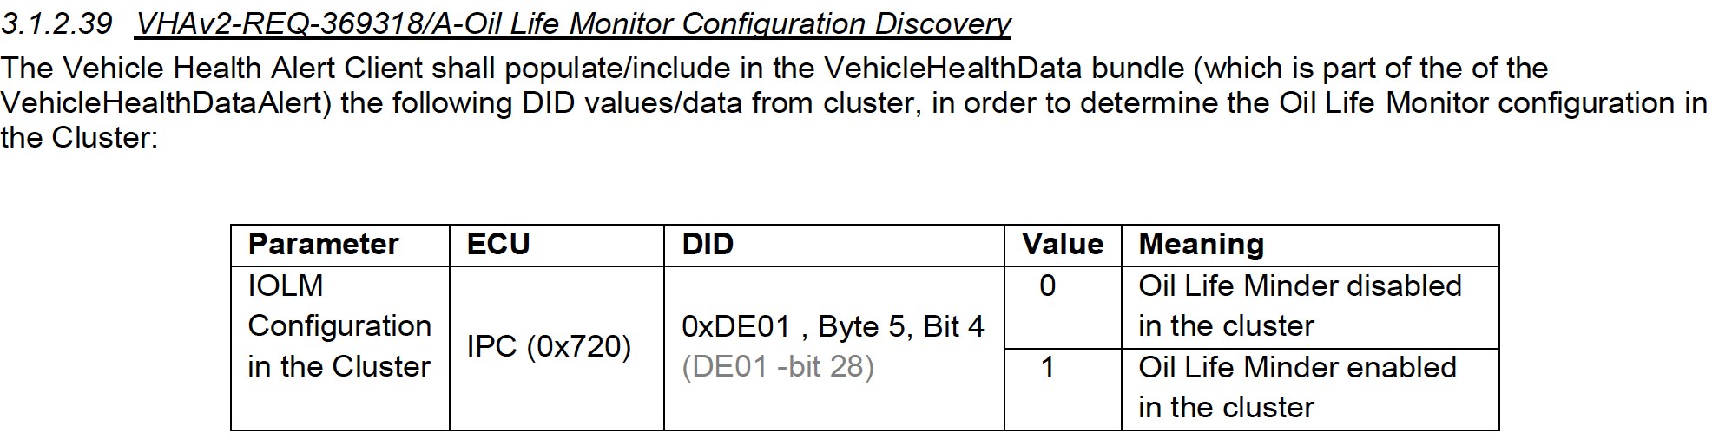

## Prognostic data collection CAN signal

OdometerMasterValue

EngOilLife_Pc_Actl

# CAN signals

Other CAN signals required:

Ignition_Status

Veh_V_ActlEng

BattTracSoc_Pc_Dsply

VehElRnge_L_Dsply

# Q&A

N/A